**EXPERIMENT 2**

**14BEE030**

Circuit Diagram Bipolar Sinusoidal Modulation

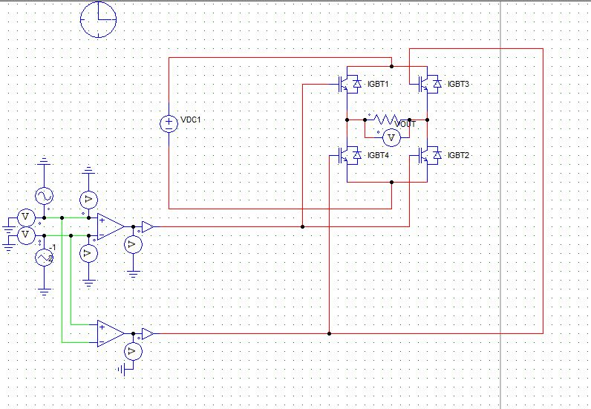

Comparison of Reference and carrier waveforms:-

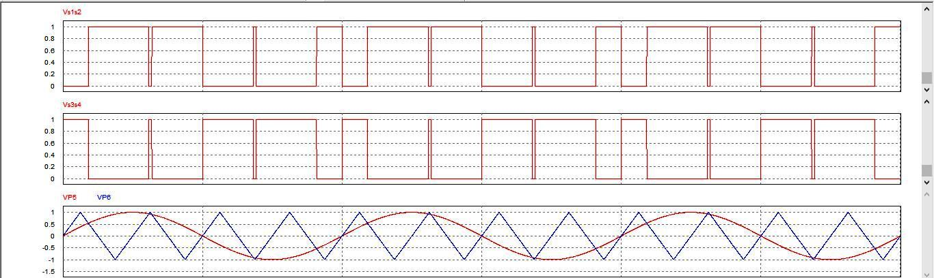

Output waveform:-

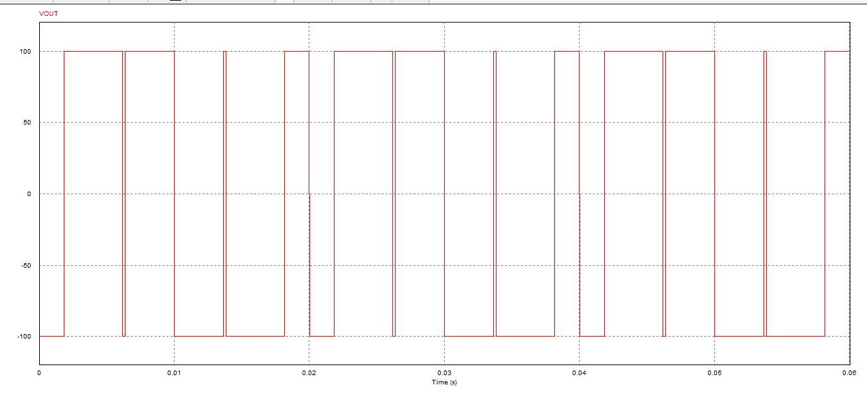

Circuit Diagram Unipolar Sinusoidal PWM:-

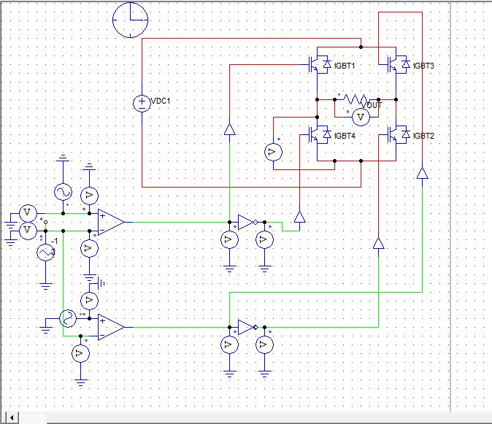

Comparison of Reference and Carrier Waveforms:-

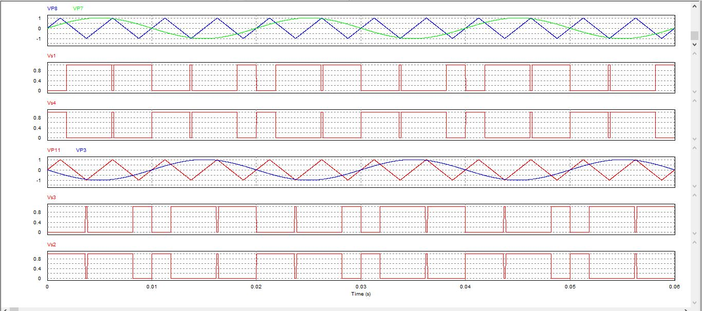

Output Waveform:-

